Strategy 2030
Clean power, built to last.
Dr. Amara Okafor · 04 March 2026 · WE-STR-2030

Why we need a new strategy
Weyland has grown from a developer of onshore wind farms in northern Germany to an independent power producer with 1.1 GW in operation across Germany, the UK and Denmark. 2025 was our best year so far: revenue grew by 13 % to EUR 312 m and EBITDA reached EUR 148 m. With Harrow Bay (480 MW) we are taking the biggest investment decision in our history. At the same time, power markets have become more volatile, grid capacity is scarce and the competition for good sites and skilled people is intense.
Strategy 2030 answers one question: how do we double the size of Weyland without losing what makes us good – reliable assets, strong partnerships with communities and a safe working environment? Our answer is summarised in our promise: Clean power, built to last.

Our ambition for 2030
Target | 2025 | 2030
Operating capacity | 1.1 GW | 2.5 GW
Revenue | EUR 312 m | EUR 600 m
EBITDA margin | 47 % | ≥ 45 %
CO₂ avoided per year | 1.2 Mt | 2.6 Mt
Employees | 450 | ~ 620
TRIR (per million hours) | 2.1 | < 2.0

Pillar 1 – Offshore wind
Harrow Bay is the anchor of the strategy. Delivered on time and on budget, it will add around EUR 150–160 m EBITDA per year from 2029. We will use the experience and the supply chain relationships built at Harrow Bay to develop two follow-on sites in the North Sea with a combined capacity of around 1.6 GW, with FID for the first one targeted for 2029.

Pillar 2 – Solar and storage
Solar and battery storage can be built quickly and close to demand. Millbrook Solar & Storage (85 MWp with a 20 MW / 40 MWh battery) and Fenwick Battery Storage (100 MW / 200 MWh) are the first projects of a 1.4 GW solar and storage pipeline. Co-locating batteries with our wind and solar assets improves capture prices and reduces curtailment.

Pillar 3 – Flexibility and hydrogen
Together with Arcturus Steel AG we are studying a 5 MW PEM electrolyser at the Port of Eastholm. The pilot is small, but it lets us learn how to supply round-the-clock green energy to industrial customers – the same customers who sign long-term PPAs such as WE-PPA-2026-004.
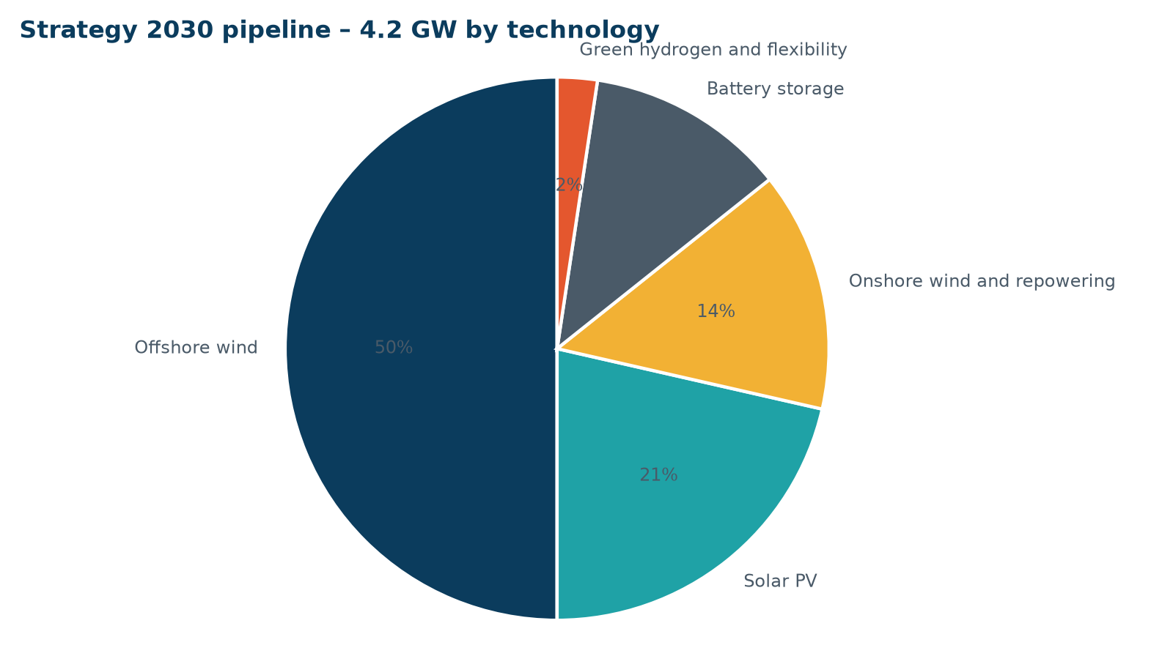
Strategy 2030 pipeline of 4.2 GW by technology

How we will fund it
Jonas to add the funding plan (capital recycling, project finance share).

